**AIM :**

Design an activity for STUDENT REGISTRATION FOR SCHOLARSHIP. Design a form to accept roll number, name, Phone Number and marks of the student. On click of REGISTER button create/open Existing database, and store the information entered by student in the student table. Once the entry to the database is complete Send the SMS to the student that he has successfully registered for the scholarship. Make sure the student can register for only one time. Place a RESET button to reset all fields and a VIEW ALL APPLICATIONS button to display all rows of the student table.

**XML Code:**

<?xml version="1.0" encoding="utf-8"?>

<RelativeLayout xmlns:android="http://schemas.android.com/apk/res/android"

android:layout_width="match_parent"

android:layout_height="match_parent"

android:padding="16dp">

<EditText

android:id="@+id/editTextRollNumber"

android:layout_width="match_parent"

android:layout_height="wrap_content"

android:hint="Roll Number" />

<EditText

android:id="@+id/editTextName"

android:layout_width="match_parent"

android:layout_height="wrap_content"

android:hint="Name"

android:layout_below="@id/editTextRollNumber"

android:layout_marginTop="8dp" />

<EditText

android:id="@+id/editTextPhoneNumber"

android:layout_width="match_parent"

android:layout_height="wrap_content"

android:hint="Phone Number"

android:inputType="phone"

android:layout_below="@id/editTextName"

android:layout_marginTop="8dp" />

<EditText

android:id="@+id/editTextMarks"

android:layout_width="match_parent"

android:layout_height="wrap_content"

android:hint="Marks"

android:inputType="numberDecimal"

android:layout_below="@id/editTextPhoneNumber"

android:layout_marginTop="8dp" />

<Button

android:id="@+id/buttonRegister"

android:layout_width="wrap_content"

android:layout_height="wrap_content"

android:text="Register"

android:layout_below="@id/editTextMarks"

android:layout_marginTop="16dp"

android:layout_alignParentStart="true" />

<Button

android:id="@+id/buttonReset"

android:layout_width="wrap_content"

android:layout_height="wrap_content"

android:text="Reset"

android:layout_below="@id/buttonRegister"

android:layout_marginTop="8dp"

android:layout_alignParentStart="true" />

<Button

android:id="@+id/buttonViewAll"

android:layout_width="wrap_content"

android:layout_height="wrap_content"

android:text="View All Applications"

android:layout_below="@id/buttonReset"

android:layout_marginTop="8dp"

android:layout_alignParentStart="true" />

<ListView

android:id="@+id/listViewApplications"

android:layout_width="match_parent"

android:layout_height="wrap_content"

android:visibility="gone"

android:layout_below="@id/buttonViewAll"

android:layout_marginTop="16dp" />

</RelativeLayout>

**MAIN JAVA Code:**

package com.example.practical8;

import android.os.Bundle;

import android.view.View;

import android.widget.ArrayAdapter;

import android.widget.Button;

import android.widget.EditText;

import android.widget.ListView;

import android.widget.Toast;

import androidx.appcompat.app.AppCompatActivity;

import java.util.ArrayList;

public class MainActivity extends AppCompatActivity {

private ArrayList<String> applicationsList;

private ArrayAdapter<String> adapter;

private EditText editTextRollNumber, editTextName, editTextPhoneNumber, editTextMarks;

private Button buttonRegister, buttonReset, buttonViewAll;

private ListView listViewApplications;

@Override

protected void onCreate(Bundle savedInstanceState) {

super.onCreate(savedInstanceState);

setContentView(R.layout.*activity_main*);

// Initialize UI components

editTextRollNumber = findViewById(R.id.*editTextRollNumber*);

editTextName = findViewById(R.id.*editTextName*);

editTextPhoneNumber = findViewById(R.id.*editTextPhoneNumber*);

editTextMarks = findViewById(R.id.*editTextMarks*);

buttonRegister = findViewById(R.id.*buttonRegister*);

buttonReset = findViewById(R.id.*buttonReset*);

buttonViewAll = findViewById(R.id.*buttonViewAll*);

listViewApplications = findViewById(R.id.*listViewApplications*);

// Initialize the applications list

applicationsList = new ArrayList<>();

adapter = new ArrayAdapter<>(this, android.R.layout.*simple_list_item_1*, applicationsList);

listViewApplications.setAdapter(adapter);

// Register button click listener

buttonRegister.setOnClickListener(new View.OnClickListener() {

@Override

public void onClick(View v) {

registerStudent();

}

});

// Reset button click listener

buttonReset.setOnClickListener(new View.OnClickListener() {

@Override

public void onClick(View v) {

resetFields();

}

});

// View All Applications button click listener

buttonViewAll.setOnClickListener(new View.OnClickListener() {

@Override

public void onClick(View v) {

viewAllApplications();

}

});

}

private void registerStudent() {

String rollNumber = editTextRollNumber.getText().toString().trim();

String name = editTextName.getText().toString().trim();

String phoneNumber = editTextPhoneNumber.getText().toString().trim();

String marks = editTextMarks.getText().toString().trim();

// Check if fields are empty

if (rollNumber.isEmpty() || name.isEmpty() || phoneNumber.isEmpty() || marks.isEmpty()) {

Toast.*makeText*(this, "Please fill all fields", Toast.*LENGTH_SHORT*).show();

return;

}

// Create a string representation of the student data

String studentInfo = "Roll Number: " + rollNumber + ", Name: " + name + ", Phone: " + phoneNumber + ", Marks: " + marks;

// Add the student information to the list

applicationsList.add(studentInfo);

adapter.notifyDataSetChanged();

// Clear the input fields

resetFields();

Toast.*makeText*(this, "Registration Successful!", Toast.*LENGTH_SHORT*).show();

}

private void resetFields() {

editTextRollNumber.setText("");

editTextName.setText("");

editTextPhoneNumber.setText("");

editTextMarks.setText("");

}

private void viewAllApplications() {

if (applicationsList.isEmpty()) {

Toast.*makeText*(this, "No Applications Found", Toast.*LENGTH_SHORT*).show();

return;

}

// Make the ListView visible

listViewApplications.setVisibility(View.*VISIBLE*);

}

}

**OUTPUT:**

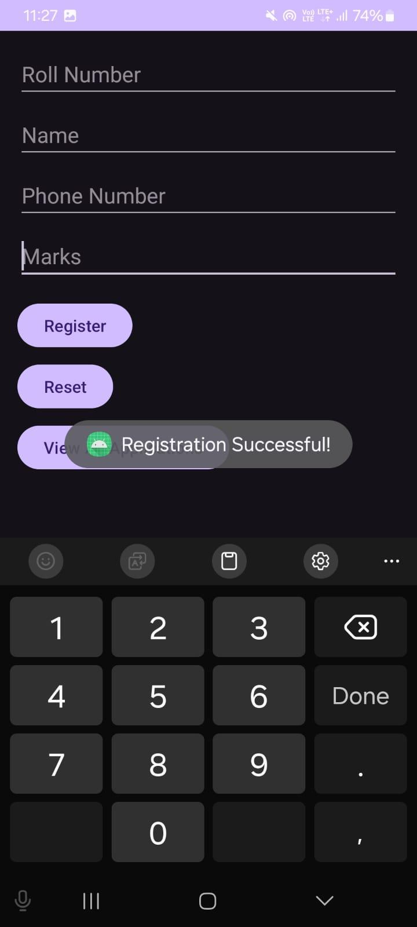

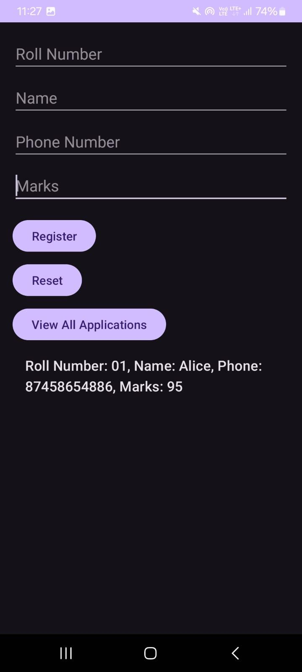

**Conclusion:**

In this practical, we developed an Android application that facilitates student registration for a scholarship program using a RelativeLayout for the user interface. The application allows users to input essential information such as roll number, name, phone number, and marks through user-friendly EditText fields. It features interactive buttons for registering students, resetting input fields, and viewing all applications, enhancing user experience and engagement. The use of an ArrayList for data management simplifies the handling of student registrations, while a hidden ListView dynamically displays the entries when available. Overall, this project provided valuable hands-on experience in Android app development, covering key concepts such as UI design, event handling, and basic data management.